Laravel Modules 8/24/2021

https://nwidart.com/laravel-modules/v6/introduction

Prerequisites: It assumes you have PHP, MySQL, Composer, Node.js, Npm installed on your system.

Run the commands marked in bold dark-blue

composer create-project --prefer-dist laravel/laravel:^7.0 project_name

composer create-project --prefer-dist laravel/laravel project_name

composer create-project --prefer-dist laravel/laravel laravel-modules

cd project_name
php artisan –V
Laravel Framework 8.56.0

git init
git add .
git commit –m "Comment"

git remote add origin https://github.com/SergeyHub/repository-name.git
git push -u origin master

Edit env. file

mysql -u root -p
create database db_name;
drop database db_name;
exit

composer require laravel/ui
composer require laravel/ui "^2.4" 7

php artisan ui bootstrap
php artisan ui bootstrap --auth

php artisan ui vue
php artisan ui vue --auth

npm i axios vform

npm install && npm run dev
npm run watch

php artisan migrate
php artisan serve

composer require nwidart/laravel-modules

php artisan vendor:publish --provider="Nwidart\Modules\LaravelModulesServiceProvider"

Autoloading
By default the module classes are not loaded automatically. You can autoload your modules using psr-4. For example :

"autoload": {
"psr-4": {
"App\\": "app/",
"Database\\Factories\\": "database/factories/",
"Database\\Seeders\\": "database/seeders/",
"Modules\\": "Modules/"
}

Tip: Don't forget to run composer dump-autoload afterwards

php artisan module:make Blog

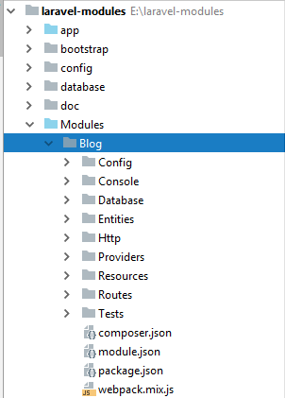

php artisan list

module
module:delete Delete a module from the application
module:disable Disable the specified module.
module:dump Dump-autoload the specified module or for all module.
module:enable Enable the specified module.
module:install Install the specified module by given package name (vendor/name).
module:list Show list of all modules.
module:make Create a new module.
module:make-command Generate new Artisan command for the specified module.
module:make-controller Generate new restful controller for the specified module.
module:make-event Create a new event class for the specified module
module:make-factory Create a new model factory for the specified module.
module:make-job Create a new job class for the specified module
module:make-listener Create a new event listener class for the specified module
module:make-mail Create a new email class for the specified module
module:make-middleware Create a new middleware class for the specified module.
module:make-migration Create a new migration for the specified module.
module:make-model Create a new model for the specified module.
module:make-notification Create a new notification class for the specified module.
module:make-policy Create a new policy class for the specified module.
module:make-provider Create a new service provider class for the specified module.
module:make-request Create a new form request class for the specified module.
module:make-resource Create a new resource class for the specified module.
module:make-rule Create a new validation rule for the specified module.
module:make-seed Generate new seeder for the specified module.
module:make-test Create a new test class for the specified module.
module:migrate Migrate the migrations from the specified module or from all modules.
module:migrate-refresh Rollback & re-migrate the modules migrations.
module:migrate-reset Reset the modules migrations.
module:migrate-rollback Rollback the modules migrations.
module:migrate-status Status for all module migrations
module:publish Publish a module's assets to the application
module:publish-config Publish a module's config files to the application
module:publish-migration Publish a module's migrations to the application
module:publish-translation Publish a module's translations to the application
module:route-provider Create a new route service provider for the specified module.
module:seed Run database seeder from the specified module or from all modules.
module:setup Setting up modules folders for first use.
module:unuse Forget the used module with module:use
module:update Update dependencies for the specified module or for all modules.
module:use Use the specified module.
module:v6:migrate Migrate laravel-modules v5 modules statuses to v6.

php artisan module:delete Blog

http://127.0.0.1:8000/blog

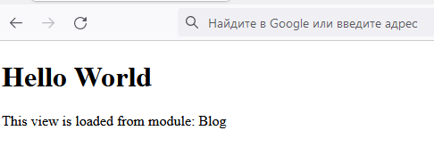

php artisan module:make ShoppingCart Cart News Product Promo

e:\laravel-modules>php artisan module:list
+--------------+---------+----------+-----------------------------------------+
| Name | Status | Priority | Path |
+--------------+---------+----------+-----------------------------------------+
| Blog | Enabled | 0 | E:\laravel-modules\Modules/Blog |
| Cart | Enabled | 0 | E:\laravel-modules\Modules/Cart |
| News | Enabled | 0 | E:\laravel-modules\Modules/News |
| Product | Enabled | 0 | E:\laravel-modules\Modules/Product |
| Promo | Enabled | 0 | E:\laravel-modules\Modules/Promo |
| ShoppingCart | Enabled | 0 | E:\laravel-modules\Modules/ShoppingCart |
+--------------+---------+----------+-----------------------------------------+

Edit E:\laravel-modules\resources\views\layouts\app.blade.php

<div class="collapse navbar-collapse" id="navbarSupportedContent">
<!-- Left Side Of Navbar -->
<ul class="navbar-nav mr-auto">
@if(Module::collections()->has('Blog'))
<li class="nav-item">
<a class="nav-link" href="/blog">Blog</a>
</li>
@endif
@if(Module::collections()->has('Cart'))
<li class="nav-item">
<a class="nav-link" href="/cart">Cart</a>
</li>
@endif
@if(Module::collections()->has('News'))
<li class="nav-item">
<a class="nav-link" href="/news">News</a>
</li>
@endif
@if(Module::collections()->has('Product'))
<li class="nav-item">
<a class="nav-link" href="/product">Product</a>
</li>
@endif
@if(Module::collections()->has('Promo'))
<li class="nav-item">
<a class="nav-link" href="/promo">Promo</a>
</li>
@endif
</ul>

Edit E:\laravel-modules\Modules\Blog\Resources\views\index.blade.php

@extends('layouts.app')
@section('content')
<div class="container">
<div class="row justify-content-center">
<div class="col-md-8">
<div class="card">
<div class="card-header">{{ __('Blog Module') }}</div>
<div class="card-body">
@if (session('status'))
<div class="alert alert-success" role="alert">
{{ session('status') }}
</div>
@endif
Blog Module
{{ __('You are logged in Blog !') }}
</div>
</div>
</div>
</div>
</div>
@endsection
@section('content')
<h1>Hello World</h1>
<p>
This view is loaded from module: {!! config('blog.name') !!}
</p>
@endsection

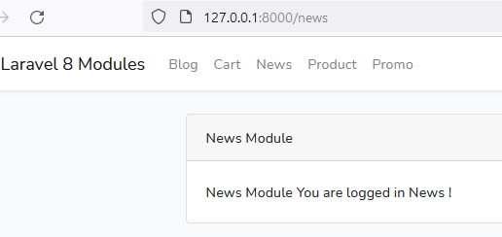

sudo chmod -R 775 storage/framework
sudo chmod -R 775 ./storage/logs
chmod -R 775 bootstrap/cache

sudo service apache2 restart

sudo chmod -R 777 /var/www/html Never use 777. With 777 permissions, you are giving anyone with a connection full access to the files or directories with those permissions. They may alter them in any way they choose, including maliciously. Many account hacking incidents stem from 777 permissions.

the requested url was not found on this server. Laravel

1. edit the apache2 conf to allow for symlinks etc
sudo nano /etc/apache2/apache2.conf

2. Add this to the file

<Directory /var/www/html/>
Options Indexes FollowSymLinks
AllowOverride all
Require all granted
</Directory>

3. Restart your apache2 server

sudo service apache2 restart

